**--After downloading CSV GZ files for Each Network: Next Steps in Humana Files for Transparency in Coverage**

The following steps explain work to extract specific billing codes from the files saved on the Humana website. Create a sample list of EINs from the state of Indiana.

If we want to limit to certain employers, we can do this first step:

1. Extract EINs from the Index JSON files, then search over the list of EINs for Indiana from step 1.
2. Obtain the .csv files for those employers from the locations listed in the Index JSON
3. Extract Billing Code, Negotiated Amount, etc. for Indiana based employers.

**Step: 1 - Create a sample list of EINs from the state of Indiana**

1.a) Since the location of the employers is not mentioned as part of the Humana files, we must gather the information of the location for most of the employers possible as we must study for the state of Indiana. Referred three different lists which are Dol 5500, Sec Ids, and IRS details for non-profit employers to collect EIN details with the location.

**Dol 5500** – It is an annual report, filed with the U.S. Department of Labor (DOL) that contains information about a 401(k) plan's financial condition, investments, and operation.

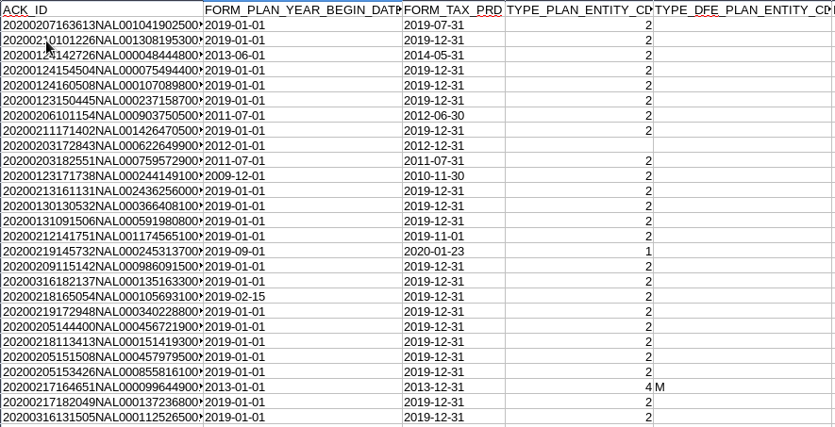

**SEC IDs –** A unique identifier assigned by the Securities and Exchange Commission (SEC) to each series of an investment company. The format is an "S" followed by nine digits.

**IRS -** In order to obtain the EINs for non-profit organizations, it will be helpful check the IRS details for location information and compare the negotiated rates.

1.b) After gathering all the information on different EINs including profit and non-profit organizations. Create a table/ data frame with “tag” as name of the source from which the EIN is extracted Dol 5500/SEC/IRS, “plan_id”/EINs, “name” of the organization, “city” and the “state”. While doing so we made sure that those EINs are part of the Humana plan as in step 1, we got the EINs for Humana.

1.c) Then put a filter to segregate EINs from the state of “Indiana”.

**Step: 2 - Extract EINs from the Index JSON files, then search over the list of EINs for Indiana from step 1**

2.a) All the filenames that are stored in the Humana server are part of the Filenames JSON and we download only the index JSON files which consist of the plan name, plan ids/EINs, and the hyperlinks for the CSV GZ files. A sample of the JSON file format is shown below:

2.b) Created a table or data frame with columns as “plan_name”, “plan_id_type”, “plan_id” / EIN, “plan_market_type”, “fname”/filename of the index JSON file. This helps to get all the employers covered by the insurer Humana.

The code for above mentioned steps is saved in /N/project/TIC/Humana/code_final/Obtain_Indiana_EINs.ipynb.

**Step: 3 - Obtain the .csv files for those employers from the locations listed in the Index JSON**

3.a) After getting the desired plan_id/EIN which are only part of the Indiana state, we download all the CSV GZ files consisting of the attributes like negotiated rates, negotiated type, etc. from the index JSON files which are from the employers as part of Indiana state and maintain a dictionary which takes care of not repeating the CSV GZ files which are already downloaded.

3.b) In order to ease the process of download, we reverse engineered the CSV GZ links to make it dynamic in nature as shown below:

https://prod-developers.humana.com/Resource/DownloadPCTFile?fileType=innetwork&fileName= {filename}

e.g., 2022-07-21_2_in-network-rates_000000017710.csv.gz

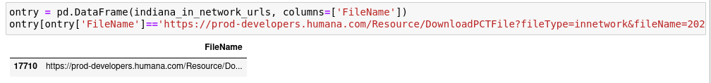3.c) The download of the specific CSV GZ was parallelized with the help of batch processing because the site was blocking the bulk download was it was getting timed out again and again using the code as shown below:

The code for above mentioned steps is saved in /N/project/TIC/Humana/code_final/Download_Files.py

**Step: 4 - Extract Billing Code, Negotiated Amount, etc. for Indiana based employers**

4.a) Once all the required CSV GZ files are downloaded then we shortlisted the below mentioned billing codes:

|  |  |  |  |
| --- | --- | --- | --- |
| **Sl. No.** | **Billing Code** | **Description** | **Simple Language Description** |
| 1 | 99213 | OFFICE/OUTPATIENT VISIT EST | Established patient office or other  outpatient visit, typically 15 minutes |
| 2 | 45378 | DIAGNOSTIC COLONOSCOPY | Diagnostic examination of large bowel  using an endoscope |
| 3 | 73721 | MRI JNT OF LWR EXTRE W/O DYE | MRI of lower extremity joint  (knee/ankle) without dye |
| 4 | 27130 | TOTAL HIP REPLACEMENT | Arthroplasty, acetabular and proximal femoral prosthetic replacement (total hip arthroplasty), with or without autograft or allograft |
| 5 | 80061 | LIPID PANEL | Blood test, lipids (cholesterol and  triglycerides) |
| 6 | 99285 | Emergency dept visit | Emergency department visit, problem  with significant threat to life or  function |

4.b) The code used to extract the details of the billing code is as follows:



NOTE: The code location is ““/N/project/TIC/Humana/code_final/Humana_Billing_Code.py”

Future Work:

• Add EINs as part of the final billing code file to analysis negotiated rated according to the various employers.